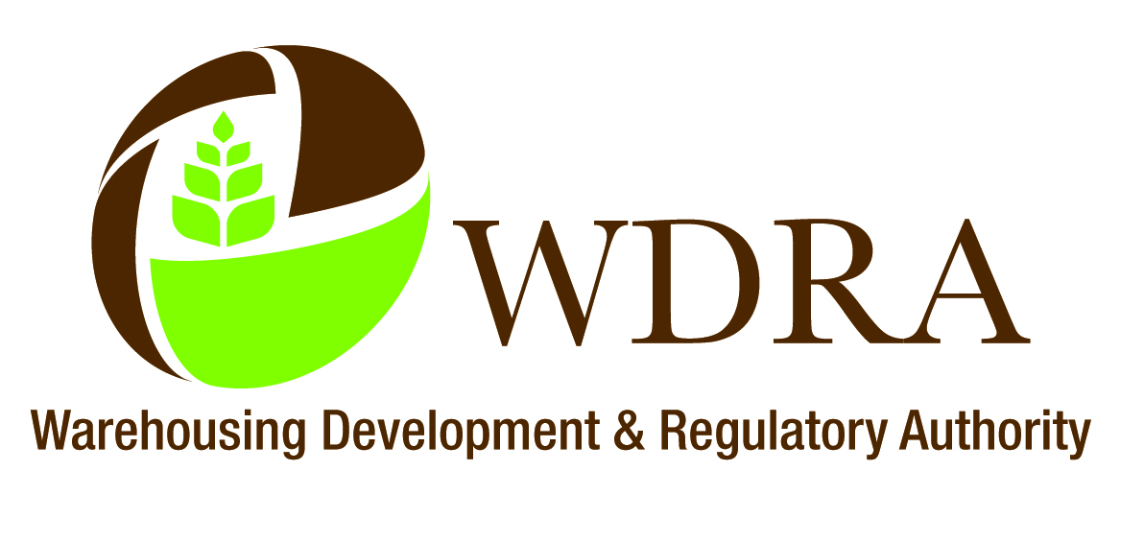

WAREHOUSING DEVELOPMENT AND REGULATORY AUTHORITY
(Government of India)
Ministry of Consumer Affairs, Food & Public Distribution,
(Department of Food and Public Distribution)

Warehousing Bhawan, 4/1, Institutional Area,
August Kranti Marg, Hauz Khas, New Delhi – 110 016

Speed Post.
F. No. WDRA/2014/17-1/Tech II Dated: 20-05-2014.

CIRCULAR NO. 01/2014

Subject : - Inspection of registered warehouses by accreditation agencies on behalf of the WDRA – regarding.

The Warehousing Development and Regulatory Authority (WDRA) has established an inspection system for registered warehouses with following objectives:

i. to ensure that the infrastructure, operational procedures and other provisions prescribed under the Warehousing (Development and Regulations) Act, 2007 the rules and regulations, and those as checked by the accreditation agencies at the time of accreditation of warehouses are complied and followed by the registered warehouses.

ii. to protect the integrity of negotiable warehouse receipts.

2. For the purpose, the WDRA has specified the following criteria for the selection of inspection agencies:

a. The inspection agency shall be independent of the warehouse inspected.
b. Staff of Inspection Agency responsible for carrying out the inspection shall not have any employment and commercial interest relationship for last two years prior to inspection.
c. Inspection Agency and its staff shall not engage in any activities that may conflict with their independence of judgment and integrity in relation to their inspection activities. In particular they shall not become directly involved in the management of competitive warehouse
d. The procedures under which the body operates shall be administered in a non-discriminatory manner.

3. It has, for the present, been decided that some of the accreditation agencies may be appointed as inspection agencies for the inspection of warehouses which are not accredited by them. Accordingly, based on their performance and with their consent, the following accreditation agencies have been listed for inspection of registered warehouses:

Cont’d......

-2-
Sl. No. | Name of the Accreditation Agencies approved by the WDRA for inspection of warehouses | States allotted for inspection.
1. | National Institute of Agricultural Management (NIAM), Jaipur. | Rajasthan, M.P, Punjab, Haryana, U.P, Gujarat, Maharashtra.
2. | National Cooperative Development Corporation (NCDC), New Delhi. | All India
3. | National Productivity Council (NPC), New Delhi.
4. | NABARD Consultancy Services (P) Ltd. (NABCONS), Mumbai. | All India
5. | American Quality Assessors (India) Pvt. Ltd Hyderabad. | A.P, Karnataka, Maharashtra
6. | SSRA & Company, New Delhi. | All India.
7. | TQ Tata Projects Quality Services, Hyderabad. | All India.
8. | Vexil, New Delhi. | Delhi, AP, Tamilnadu, Kerala and Karnataka

4. The names of other agencies including accreditation agencies if found eligible may be added by the WDRA and in case the performance of selected agencies is not found satisfactory, their names may be deleted from the list.

5. The inspection agency would carry out the inspection of warehouses as per the directions of the WDRA. The names of the warehouses to be inspected would be communicated to the inspection agency by the WDRA and the inspection agency would carry out the inspection of warehouses as per the checklist annexed with this circular. The WDRA may revise the checklist from time to time. All the information as per the checklist would be collected and verified by the inspection agency.

6. The WDRA may specify other parameters from time to time to be checked by the inspection agencies.

7. The WDRA will pay the following inspection fee to the inspection agency:
Sl. No. | Capacity of the Warehouse | Inspection Fee per year
1. | Upto 10,000 MTs | Rs. 7,500/- for one inspection.
2. | More than 10,000 MTs | Rs. 15,000/- for one inspection.

The WDRA would not pay any additional charges incurred by the inspection agencies for the travel of their inspection officers.

8. The information in the checklist should be signed by the warehouseman as a token of his acceptance. The agency would share the inspection report with the warehousemen.

9. The inspection agency will submit the inspection report along with checklist duly filled and signed by the inspecting officers to the WDRA within 15 days of completion of inspection. The report would be submitted to the Director (Tech) of the WDRA along with the bill for reimbursement of inspection fee from the WDRA.

continued

-3-

10. All the inspection agencies are required to carry out the inspection of registered warehouses as per the guidelines issued by the WDRA and they should check the requirements in the Act, Rules and Regulations while carrying out the inspection of registered warehouses.

11. The WDRA will organise training programme for the officers of inspection agencies from time to time.

Yours faithfully,
Enclosure: As above,

(Ms. Yatinder Prasad),
Director (Admn. & Fin.).
Tel. 26536214.

Distribution:

1. The MD, CWC, Corporate Office, New Delhi.
2. The MDs of all SWCs.
3. All the WSPs/Owners/Managers of registered warehouses with the WDRA.
4. All accreditation agencies registered with the WDRA.

Copy to:

The Chairman/Members & Officers of WDRA

Checklist to be Filled up by the Examiners of Inspection Agency
1. | Name of the inspection agency alongwith name & designation of inspecting officer(s) with e-mail address and mobile no.
2. | Date of inspection
3. | Complete address of the registered warehouse | i. Name of warehouse: _______________________________________  ii. Plot No.:______________________  iii. Village/Town/ City: _____________________________________  iv. Taluka: ____________________  v. District:__________________  vi. State:______________________, Pin No.:______________  vii. Tele/Mobile No:_________________  viii. Fax No.:______________________  ix. E-mail address:__________________
4. | Registration no. of the warehouse along with valid period of registration. | i. Registration No.____________________  ii. Period: From______________ to ______________
5. | Name of the warehouseman | i. Name of the warehouseman (in whose name the registration certificate is issued): __________________________________  ii. Name of the present warehouseman (in case, the warehouseman is changed):___________________________________________  iii. Whether the modified certificate issued by WDRA after changing the name of the warehouseman: Yes / No
6. | Storage Capacity | i. Total storage capacity in MTs:_____________________  ii. Registered capacity in MTs:____________________  iii. Shed No./Compartment No.(s) of registered capacity :___________  ___________________________________________________________
7. | Name of the Accreditation Agency which had accredited the warehouse
8. | Details of Ownership/operator of the warehouse. | i. Name of the owner of the warehouse:_______________________  ii. Proof of ownership: (a) Sale deed:_________________________  iii. In case hired godown, please mention about:  (a) name of the operator:  (b) validity of lease agreement and whether registered:  (c) validity of rent agreement and whether registered and rent receipt:  (d) validity of profit sharing agreement and whether registered:

9. | Whether the registered warehouse is maintaining the construction standards as per BIS/ CWC/ FCl Standards?
10. | Observations about storage worthiness of the warehouse(s) with details. | i. Observations about:  (a) Cleanliness and hygienic:  (b) Insect infestation, if any:  (c) Rodent infestation, if any:  (d) Bird problem, if any:  (e) Proper stacking with stack cards and proper entries:  (f) Proper hallways and alleyways have been left for inspections and other warehousing operations:  (g) Whether away from environmentally polluted area:  (i) Whether proper code of storage practices are being followed by the warehouseman, give details:
11. | Status of NOC/warehouse licence, its validity | i. Name of the authority issuing NOC/warehouse licence:  ii. Validity period:
12 | Brief about present networth of the warehouse
13 | Name of commodities for which warehouse(s) has been registered and the commodities being stored.
14 | Quality testing equipment available and their usage.
15 | Security arrangements. | i. Whether the warehouse has well maintained pucca boundary walls/barbed wire fencing:----------------------------------.  ii. Numbers of Security Guards along with their name :-----------------------------------------------------------------------------------------------------------------------------------------------------------------------------------------------------------------------------------  --------------------------------  iii. Whether gate-passes are issued for the goods passing out from the warehouse................................................................................
16 | Fire-fighting arrangements | i. No. of fire extinguisher: _____________  ii. Whether fire extinguisher are timely refilled:_______________  iii. No. of sand buckets:_________________  iv. Any other fire fighting arrangements: ________________  v. Whether inspection agency finds fire fighting arrangements as per WDRA’s norms and satisfactory: __________________  vi. Whether telephone nos. of nearest fire station are properly displayed in the warehouse:__________________________________
17 | Insurance | i. Special fire & other perils policy:  (a) Name of the insurance company: _____________________  (b) Insured amount (as per registered capacity):______________  (c) Validity period:_____________________  ii. Fidelity policy:  (a) Name of the insurance company: _____________________  (b) Insured amount (as per registered capacity):______________  (c) Validity period:_____________________  Whether insured amount adequate as per WDRA’s norms. If not, give details.
18 | System of issuing NWRs (Time taken between entry of goods in the warehouse to issue of NWRs).
19 | Normal turn around time (whether it is satisfactory ?)
20 | Details of NWR books/NWRs (since the last date of inspection by an inspection agency) | i. No. of NWR books received from WDRA: _______________________________________________________  ii. No. of NWRs issued to depositors: ______________________  ____________________________________________________  iii. Total quantity of commodities against which NWRs issued: ___  ________________________________________________________  iv. Total value for which NWRs were issued:___________________  _______________________________________________________  v. No. of NWRs discharged:___________________________  vi. Name of the important commodities for which NWRs were issued: _________________________________________________  vii. No. of balance NWRs (books and loose NWRs) and whether they tally with the physical inventory. If not, give details:  ______________________________________________________
21 | Whether NWRs forms properly filled or not? If not, then mention deficiencies in filling up of NWRs.
22. | Details of financing of NWRs | i. No. of NWRs financed by Banks/FIs:________________________  ii. Amount of loan given by Banks/FIs against NWRs: ___________  _______________________________________________________  iii. Name of the Banks/FIs: ________________________________
23 (A).  (B)  (C) | Whether the physical inventories tally with the commodities covered by the outstanding (issued) NWRs? If not, all details of discrepancies.  (Physical verification of stocks for at least 20% of outstanding NWRs or 10 NWRs, whichever is higher, on random basis).  In case of any discrepancy, details:  Detailed comments on the quality of goods stored: | NWR Sl. No. | Commodities | Quantities mentioned in the NWR | Quantity verified in the warehouse | Quality of the stock
24. | Comment on incidence of non-delivery or non-release of NWR commodities beyond a prescribed time/  reasonable storage time/beyond shelf life.
25 | Impediments, if any, in the issuance of NWRs by the registered warehouses.
26 | Whether all the aspects examined at the time of accreditation of warehouse are maintained by the warehouse? If not, mention deficiencies.
27 | Whether warehouse staff requires training? If yes, then give details about the staff and training required.
28 | Attach a photograph taken during the inspection with the warehouseman and his staff alongwith inspection team.
29 | Interact with farmers/other clients to find their satisfaction level/suggestions (if their present during inspection)
30 | Any other observation/ information about the warehouse relevant to the WDRA
31 | Whether need for farmers awareness programme near warehouse?
Note: Please attach copy of documents verified by the agency.

Signature with seal and Signature with seal and date
date of the warehouseman of the inspecting officer (s)

